Homework 6
Problem1: The Integration
1. Using the Trapezoidal Rule:
The integral of the function f(x), evaluated from a to b, is expressed as
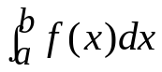 that represents the area under the function f(x) from x=a to x=b ,as
y

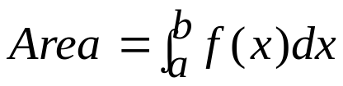
x
f(x)

a
b

Fig 1: Area under a curve
y
x
f(x)
y₁
y₂
y₃
y₄
y₅
a = x₁
x₂
x₃
x₄
x₅ = b

Fig 2: Spaced intervals
y
x
f(x)
y₁
y₂
y₃
y₄
y₅
a = x₁
x₂
x₃
x₄
X5 = b
A₁
A₂
A₃
A₄

h = x_{2 －} x₁
₌ x_{3 －} x_{2 = …}

Fig 1: Four trapezoids

The total area under the function f(x) from x₁ to x₅ is A₁＋A₂ ＋A₃＋A₄=
× ( y_{1 ＋}y₂ ) × h＋× (y₂＋y₃) × h＋× (y₃＋y₄ )× h＋× ( y_{4 ＋}y₅ ) × h
＝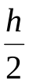× (y_{1 ＋}y₅ ) ＋（y₂＋y₃＋y₄）× h
＝＝× 〔(y_{1 ＋}y₅ ) ＋ 2 ×（y₂＋y₃＋y₄）〕
In general, Area = = 〔f(a) + f(b) + 2 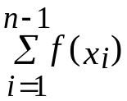 〕
where h = 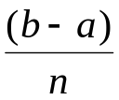, Note that the interval 〔a, b〕is divided into n subintervals
2. Using the rectangular rule:

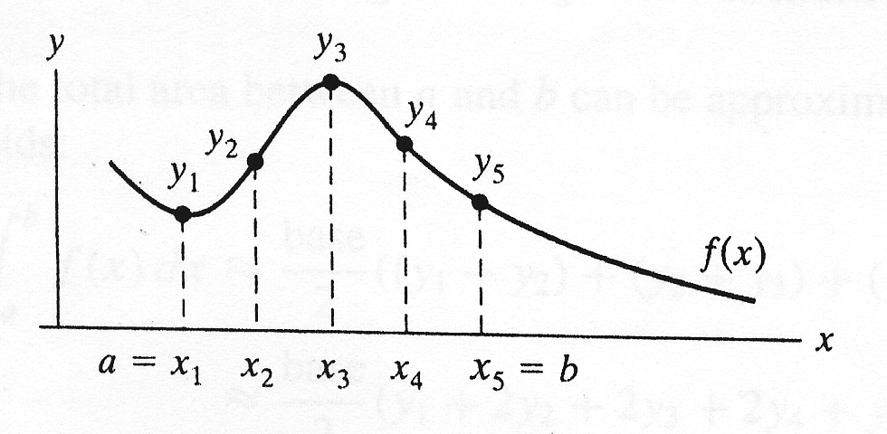
h = x_{2 －} x₁
₌ x_{3 －} x_{2 = …}

The total area under the function f(x) from x₁ to x₅ is
h × y₁ ＋h ×y₂＋h × y₃＋ h × y₄ ₌ h ×（y_{1＋}y₂＋y₃＋y₄）

In general, Area = = h × 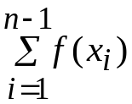

1. Using these two methods to find the area bounded by
From a= 0 b= 10 f(x) = 8 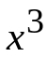＋3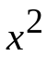＋ 6x＋ 10
Given that h = 0.1
2. From the result :
(a). Discuss these two methods.
(b). The interval 〔a, b〕is divided into n subintervals .
Increase the value of n that is decrease the value h.
You can try any other values of h.

Problem 2: Write a program that prompts the user to input three numbers. The program should then output the numbers in ascending order. (由小排到大)

Problem 3. Write a program that prompts the user to input the x-y coordinate of a point in a Cartesian plane. The program should then output a message indicating whether the point is the origin, is located on the x (or y) axis,
or appears in a particular quadrant.
For example:

(0,0) is the origin
(4,0) is on the x-axis
(0,-3) is on the y-axis
(-2,3) is in the second quadrant
(-1,-9) is in the third quadrant

Problem 4. Write a program that mimics a calculator. The program should take as input two integers and the operator that the operation to be performed. It should then output the numbers, the operators, and the result.
(For division, if the denominator is zero, output an appropriate message)

Note: please use the switch syntax to solve this problem.

Some sample outputs follow:
3 + 4 = 7
13 * 5 = 65

Problem 5. (加分題, 可以不寫) This is an extra point question, you may not write.
Write a menu-driven program that has the following options:
- Factorial of a number
- Prime or not
- Odd or even
- Exit

Once a menu item is selected, the appropriate action should be taken and once this action is finished, the menu should reappear. Unless the user selects the “Exit” option, the program should continue to work.
Hint: Make use of an infinite while and a switch statement.

